***NAME: Sitara Rehman***

***Sap: 66454 bscs***

***Subject: Operating system Lab 01***

***Submitted to : Ma’am Ayesha Akram***

***Semester: 05***

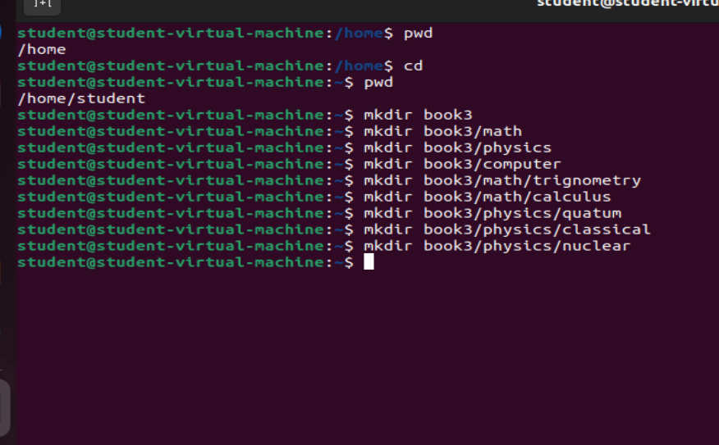

***Task01***

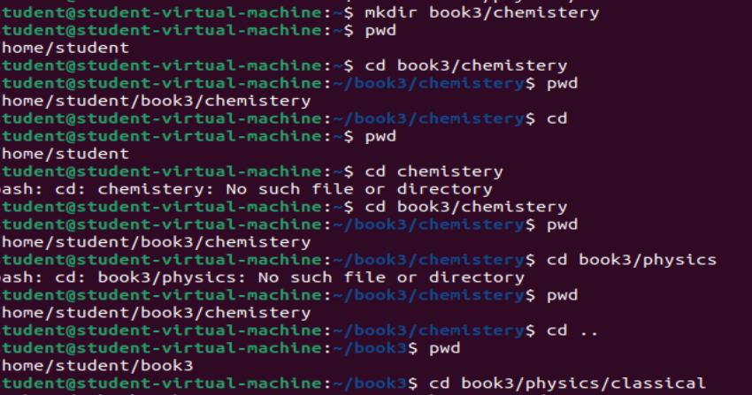

***Task02***

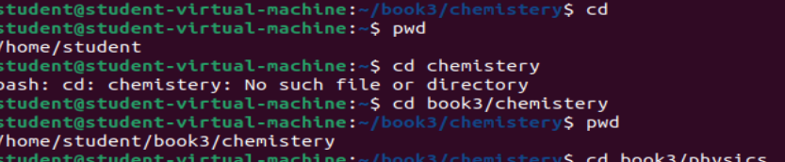

Relative path:book3/chemistery

Absolute path:/home/book3/chemistery

***Task:03***

We cannot add directly graphics under the physics sudirectory classical . First we have to go to home then use the command mkdir and create the graphics directory.

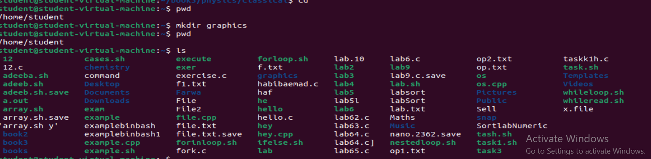

***Task:04***

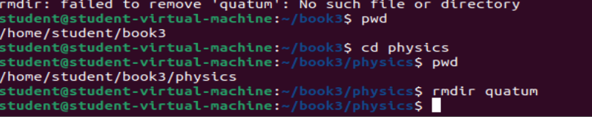

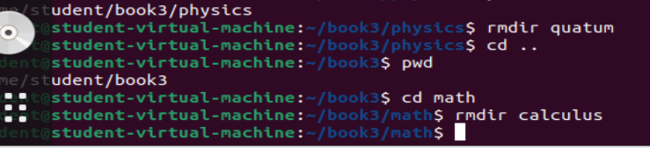

***Task:05***

Following are the Commands of Linux Directory:

Pwd: this Command is used for checking the current directory.

Ls: this is used for showing the files and folders of current directories

Ls –a:it shows all the hidden files in folders.

Ls –l:it shows all the details of the folders and files .

Ls –r: that command shows the files and folders in reverse order.

Cd directory name: through this we can move from one directory to another.

Is –l –r:it shows the folders and files in detail but in reverse order.

Cd .. : move frome current directory to parent directory.

Cd / : move current directory to home directory.

Cd :move root directory to home directory.

Mkdir directory name: creating the directory.

Rmdir directory:for removing the directory which doesn’t have further directory.

Rm –r directory name: a file having futher directory .